

**Power BI 101 Demo –**

**From scratch experience using Power BI Desktop**

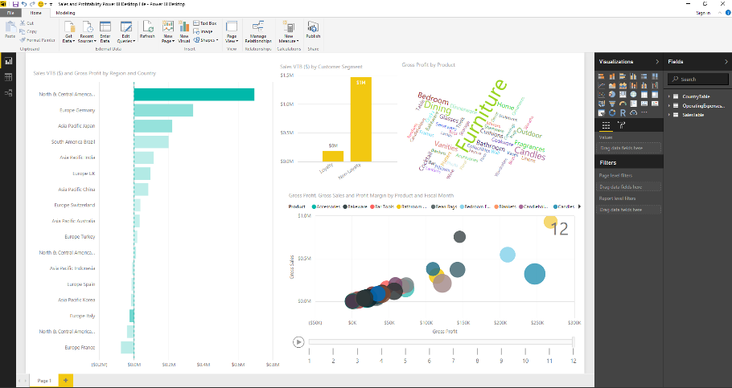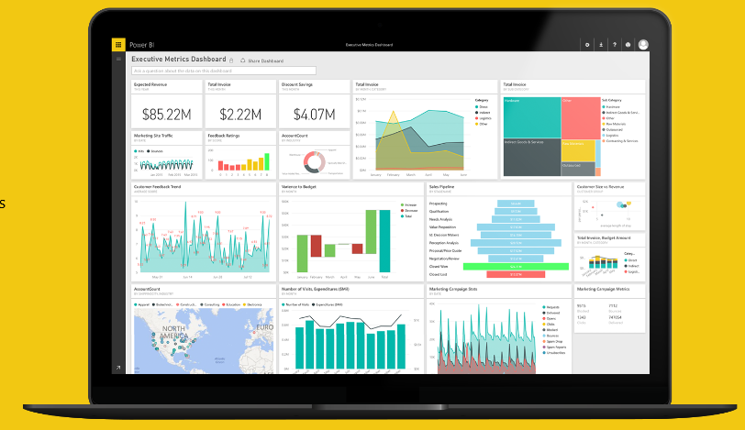

September 2016

# Contents

Contents 2

About this demo 3

Prerequisites 3

Part 1 – Connect to your data, transform and model your data 6

Part 2 – Create a report 10

Part 3 – Optional: Add a custom visual to a report 22

Part 4 – Optional: Publish to Power BI service 24

Part 5 – Optional: Power BI mobile experience 28

Conclusion 31

# About this demo

This demo provides a brief introduction to Power BI and the capabilities in Power BI Desktop to illustrate a ‘from scratch’ experience. You will connect to a data source, transform and model the data and use the powerful report design and publishing capabilities in Power BI.

# Prerequisites

| Prerequisite | Screenshot |
| --- | --- |
| 1. **Prerequisite**: You will need a Power BI account for this demo. If you do not have an account, you can sign up for free at <http://powerbi.com> |  |
| 1. **Prerequisite**: You will need Power BI Desktop installed on your machine.   Visit <http://powerbi.microsoft.com/desktop> to install the latest version of Power BI Desktop. |  |
| 1. **Prerequisite**: Save the Excel file **Sales and Expenses.xlsx** that is delivered with this demo to a folder on your machine, e.g. to Documents\Power BI Demos. |  |
| 1. **Prerequisite [optional]**: You will need to download and install the Microsoft Power BI app on your mobile device. This is required for the optional mobile portion (part 5) of this demo.   To install the app on your iPhone:   * 1. Go to the **App Store** on your iPhone   2. Search for **Microsoft Power BI**   3. Download and install the **Microsoft Power BI** app.   4. Sign in with your Power BI account. |  |

# Part 1 – Connect to your data, transform and model your data

| Narrative | Steps | Screenshot |
| --- | --- | --- |
| For this demo, let me start by stepping into the role of a Business Analyst. My work is focused on analytics, statistics, visualization and presentation. I am expected to provide consumable data to others in my organization.  For years, I have been using Excel as my primary tool to bring data together from different sources, shape and model the data according to what my business users need. I am using advanced tools in Excel like Power Query or Power Pivot to shape and model the data. I am using PivotTables and charts for analysis and visualizations, and I can distribute the Excel workbooks that I built to my business users to work with. I have become very familiar with these tools in Excel.  In this demo, I will introduce you to Power BI Desktop and its advanced query, modeling, and report creation features. As you will see, the experience that I have in using Excel will be directly useful in my experience with Power BI Desktop.  So let’s start with Power BI Desktop. | 1. Launch **Power BI Desktop** on your demo machine 2. **Close** the startup screen. |  |
| With Power BI Desktop, I can connect to all sorts of different data sources.  My business users are interested in the financial performance of the business, across geographies, products, customer segments and over time.  I know exactly where some of the data for this is stored, let’s start to connect to some data. | 1. From the **Get Data** menu, select **Excel**. |  |
| I can use and combine data from many different places. I will use a Sales and Expenses workbook which I have prepared and kept up-to-date for the business for years as my data source as it will have most of the data points that I need. | 1. **Open** the **Sales and Expenses.xlsx** file that is delivered with this demo. |  |
| I get a preview of my data and using the load function, I can import the data into Power BI Desktop.  I can further format the data in Power BI Desktop. I can also select the edit function to transform the data during the load process. This experience – the Query Editor – is consistent with what I know from Power Query in Excel. | 1. The **Navigator** dialog will show the named tables and worksheets from the Excel for selection. 2. Select the three tables **CountryTable, OperatingExpensesTable** and **SalesTable**. 3. Click on **Load**, then wait for the data load process to complete. |  |
| In Power BI Desktop, I have an intuitive experience for discovering, combining, and refining data across a wide variety of sources. | 1. Select the **Data** view icon in the left-hand navigation pane. 2. The imported tables will be shown in the Fields list.   Select **SalesTable** to inspect the data. |  |
| I have the ability to shape the data from my data sources, for example I can change the data type of selected columns in my dataset.  Very easy! | 1. Select the **Gross Sales** column. 2. Switch to the **Modeling** ribbon tab, and change the format to **Currency -> English (United States)**. 3. Set the number of decimal places to **0**. 4. Repeat this step to apply the same currency formatting to the column:   **Budget** |  |
| I also have control over how data is displayed and summarized later on in my report.  For this percentage measure, let me change the format and summarization. | 1. Select column **Sales VTB (%)**. 2. Change the **Format** to **Percentage**, with **0** decimal places. 3. Change the **Default Summarization** to **Average**. |  |
| Let’s look at the data model.  I can have relationships in our data model which will be important later on to properly analyze or visualize the data.  Power BI has automatically detected the relationship that exists between the table that I imported – I didn’t even have to do anything!  As you can see, our tables are related on the country field that exists in each of the tables. | 1. Switch to the **Relationship** view in the left-hand navigation pane. 2. Point to the relationships between the tables on the **Country** field. |  |

# Part 2 – Create a report

| Narrative | Steps | Screenshot |
| --- | --- | --- |
| The data model is now imported into Power BI Desktop and I can start to create a report for my business users. | 1. Switch to the **Report** view in the navigation pane on the left. |  |
| Let’s add a nice visualization showing sales and profit across region and countries.  This is something my business users can also do in Power BI, with the data model that I created for them.  I am selecting the Sales variance to budget, or VTB, field and the Country field. This will give me the difference in $ between budget and actual sales by country.  Power BI helps me in that it analyzes the data and chooses a default visual. If I selected **Country** first, we will get a map.  If I selected **Gross Sales** first, I will get a clustered column chart.  If I want a different visualization, I can simply change it, for example to a stacked bar chart.  Nice – I like that! | 1. From the **Fields** list on the right, select the ﻿**Sales VTB ($)**﻿ and **Country**﻿fields. 2. In the **Visualizations** pane, select **Stacked bar chart** in the top left (hover over a chart icon to see the name displayed). |  |
| We already have some insights here.  Power BI has selected a default sort order for me. At the top, I see the countries that have exceeded their sales budget the most.  At the bottom, I have the countries that have not met their sales budget, i.e. their sales variance to budget is negative. | 1. Resize the bar chart as shown. 2. Using the chart menu (**...**) in the top right, point out the default sort order by **Sales VTB ($)**. |  |
| My business users are a little more demanding than that, they also want to see profits by country.  While sales versus budget is an important performance indicator, profits are important for the bottom line.  What I can do on this chart type is add gross profit as color saturation. | 1. From the **Fields** list, select the field **Gross Profit** and drag and drop it to the **Color saturation** area. |  |
| Now my chart gives me additional insights: the darker shaded bars indicate higher gross profits, whereas the lighter shaded bars indicate lower  What I can see now is that country USA is not only exceeding budget, it is also the most profitable country.  I can also see that even though country Italy is not meeting budget targets, it is among the most profitable countries.  If I want to see the exact values, I can simply hover over one of the bars. | 1. Hover over a bar to see the values displayed. |  |
| Did I mention that my business users are demanding? There’s more I can do with this bar chart.  I can show and analyze hierarchical information, for example my business wants to see a roll-up of sales and profits by region, not only countries.  All I have to do is add the Region field on top of the Country field as my chart axis. | 1. Drag and the drop the **Region** field as a secondary field in the **Axis** area, above the **Country** field. |  |
| Now I can drill down and up between regions and countries – for yet more insights!  At a regional level, Europe is outperforming the other regions for both meeting their sales budget and for profits.  I think my business users will find this chart very useful. | 1. Use the **drill up/drill all** buttons to switch between countries and regions on the chart axis. |  |
| But there is much more data to be explored.  Let’s add another chart to the report page. We’ve got lots of room on our report canvas.  Our business has introduced a loyalty program to drive more repeat customers to buy our products.  Every time we sell a product, in-store or online, our sales system tracks whether the product was sold to a loyalty or a non-loyalty customer.  Let’s find out how we’re doing with our royalty program.  I am going to select a column chart for this, and all I have to do is add the Customer Segment and Sales variance to budget fields. | 1. Click on a blank area on the report page. 2. In the **Visualizations** pane, select the icon for **Stacked column chart**. 3. Drag and drop the field **Sales VTB ($)** to the **Value** area for the chart. 4. Drag and drop the field **Customer Segment** to the **Axis** area for the chart. |  |
| I am also going to switch over to the formatting options to change the default color for the chart.  This will add different colors to my report.  I also want to show the data values directly in my visualization, without having to hover over one of the bars. So let’s turn on data labels. | 1. On the **Format** tab change the **Default color** as shown. 2. Turn the **Data labels** to **On**. |  |
| So here is my new chart and I can already see that we are exceeding budgets in both customer segments, however far more in our non-loyalty customer segment. | 1. Your report page should look as shown. |  |
| Let’s explore this further. I want to know more about our customer segments.  The charts on a Power BI report interact with each other which allows me to find further insights.  For example, if I select the non-loyalty column here, you can see that the country bar chart is changing and showing me additional information. For each country, I can now see gross sales figures for both customer segments.  I can change this default interaction if I want to – I can filter, highlight, or turn it off completely.  That’s very powerful! | 1. Click on the **Non-Loyalty** bar of the column chart. 2. Notice how the bars on the chart to the left are now showing **Gross Sales** values for both **Loyalty** and **Non-Loyalty customers**. 3. From the **Visual Tools -> Format** menu, select **Edit Interactions**. 4. A menu will appear on top of the bar chart, allowing to switch between **Filter**, **Highlight**, or **No** interaction with the selected column chart. 5. See the different effects by switching between the interaction modes and selecting **Loyalty** or **Non-Loyalty** customers in the column chart. 6. Deselect the **Edit Interactions** button on the **Visual Tools -> Format** menu. |  |
| It can be helpful for the business users to look at the data behind the chart – this is another feature in Power BI Desktop that is very easy to do.  I have the option to see the records for a visualization.  Let’s say I want to see all records for my non-loyalty customer segment. I simply select the See Records toggle button, then on one of the columns of my chart. | 1. With the column chart still selected, go to the **Drill** tab in the **Visual Tools** menu and select the **See Records** function (toggle button). 2. Click on **the Non-Loyalty Customer** column. |  |
| Now I can see the source records behind my chart selection in a table format.  I can inspect this data and then return to my report page. | 1. The data records for the **Non-Loyalty Customer Segment** will be shown. 2. Select **Back to Report** above the data grid to return to the report. |  |
| With the See Data function, I see the aggregated data values that rendered in the chart.  Here I can see both the chart and the data below on a single page. | 1. De-select the **See Records** function. 2. Select the **See Data** command from the **Drill** menu. |  |
| Another feature in Power BI Desktop that is super helpful for me as an analyst is the ability to add measures, columns or tables to an existing data set. Often times, my source data does not have all the required data points that are needed for certain KPIs or visualizations.  With Power BI Desktop, I can use DAX formulas to add new measures.  DAX, or Data Analysis Expressions, provide me with a set of functions and operators that I am already familiar with from working with Power Pivot and Analysis Services.  In our data set, a useful insight for the business would be the profit margin for our products, however our imported data set does not offer that. I can use a DAX formula to add profit margin as a calculated measure in my dataset. | 1. From the **Modeling** tab, select **New Measure**. 2. Enter the DAX formula:   **Profit Margin = SUM(SalesTable[Gross Profit])/SUM(SalesTable[Gross Sales**   1. Set the **Formatting** of the measure to **Percentage**, with **0** decimals. 2. Set the **Home Table** of the new measure to **SalesTable**. |  |
| We have room for another chart.  I want to bring a time aspect into my report so that the business can monitor product sales and profit, month over month.  In this last step, we will add an animated scatter chart to our report.  With the scatter chart, I can show multiple measures for a product, like sales, profit and margin and how the products relate to each other for these measures.  I can use the play axis to introduce a time dimension and monitor all those aspects over time, for example the course of a year.  That’s awesome, and I am sure will give me some new insights. | 1. Click on an empty area on the report canvas. 2. From the **Visualizations** pane, select the **Scatter chart** icon. 3. Drag and drop the **Product** field to the **Legend** area for the scatter chart. 4. Drag and drop the **Gross Profit** field to the **X Axis** area for the scatter chart. 5. Drag and drop the **Gross Sales** field to the **Y Axis** area for the scatter chart. 6. Drag and drop the **Profit Margin** field to the **Size** area for the scatter chart. 7. Drag and drop the **Fiscal Month** field to the **Play Axis** area for the scatter chart. |  |
| I can play the animated scatter chart to monitor gross sales and gross profits for our main products over the course of 12 months.  I can see that sales are highest at the end of the year, with another peak mid-year.  Another insight here is that dining furniture and candles are high in both sales and profit, with candles being more profitable. | 1. You can click on a bubble (or select multiple with CRTL) to follow the animated path for that item. |  |
| Here is our final report – I think my business users will love it!  Let’s save it so we can share it with others. | 1. Your final report will look as shown on the right. 2. Click on **Save** and save the Power BI Desktop file as **PBIDemo.pbix** to your local machine. |  |

# Part 3 – Optional: Add a custom visual to a report

| Narrative | Steps | Screenshot |
| --- | --- | --- |
| As an analyst, I get excited about all the different ways I can visualize data in Power BI. I also understand that it’s important to choose the right visualization to analyze a given dataset or effectively tell the story about my data.  With Power BI, Microsoft has enabled developers to create entirely new custom visuals for Power BI that I can use in dashboards and reports. These visuals can be specific to my business or industry.  These visuals are available to me in the Power BI visuals gallery, all in one place, and growing rapidly!  I think I already see something useful here – Word Chart. I will download it from the gallery so I can use to use it to highlight product profitability on my report. | 1. Open a browser window and navigate to the **Power BI Visuals Gallery** at <http://visuals.powerbi.com>. 2. Select the **Word Cloud** visual and download it to a local folder on your machine. |  |
| In Power BI, I can add a custom visual to my palette of visualizations using the import function. | 1. Go back to your **Power BI Designer** window. 2. From the **Visualizations** pane, select the **Import from file** item (**…**). 3. In the notification dialog, select **Import**. |  |
| Now all I have to do is select the file for the Word Cloud custom visual that I downloaded from the gallery. | 1. Select the visualization file that you downloaded from the gallery, then select **Open**. |  |
| Now the Word Cloud custom visual is available to me, next to all the default visualizations in Power BI Desktop. I can work with it just as I would with any other visual.  I am going to use the Word Cloud visual to show which products lead the highest profits, in a simple view. | 1. The **Word Cloud** custom visualization will appear in the **Visualizations** pane. 2. From the **Fields** list, drag and drop **Product** to the **Category** area. 3. Drag and drop **Gross Profit** to the **Values** area. |  |
| I can see that our furniture and candles products are the most profitable ones, based on the size of the words shown. | 1. Your report will now look as shown on the right. 2. **Save** the file. |  |

# Part 4 – Optional: Publish to Power BI service

| Narrative | Steps | Screenshot |
| --- | --- | --- |
| Now that I am done with the data preparation and the creation of an initial report, I want to share my work with my business users.  Power BI makes this easy for me with a built-in Publish functionality in Power BI Desktop. This allows me to share, or publish, my data model and report with other users. | 1. In Power BI Desktop select **File -> Publish -> Publish to Power BI or click on Publish on the ribbon.** |  |
| When I choose to publish from Power BI Desktop, the PBIX file with the data model and reports is uploaded to the Power BI service. | 1. You will be prompted to sign in to Power BI. 2. After successful publishing, click on the link to open your PBIX file in the Power BI service. 3. The report will be displayed in the Power BI service (browser). |  |
| Once the file is published, I can start working with it in the Power BI service.  Let me now also create a dashboard that I will share with my business users.  I will select a chart from my report and pin it to a dashboard. | 1. Select the **Sales** bar chart on the left of the report page, then click on the **Pin** icon of the chat. |  |
| If I don’t want to use an existing dashboard, I can create a new one as I pin the visual. | 1. Choose to pin the visual to a **New dashboard**. 2. Enter a name for the dashboard, then click **Pin**. |  |
| Let’s add another chart to the new dashboard. | 1. **Pin** the scatter chart to the same dashboard. |  |
| Every chart that I pin is represented as a tile on my dashboard. I can resize and rearrange the tiles to my preference. | 1. From the left-hand navigation in Power BI, select the newly created dashboard. 2. Resize and arrange the dashboard tiles as shown on the right. |  |
| Q&A is a very useful feature in Power BI for my business users.  All you have to do is type a question about your data and Power BI will provide you with suggested terms and answers. The answers are provided based on the data model and report that I uploaded earlier. | 1. At the top of the dashboard, in the field **Ask a question about your data** (Q&A) type the question   **show profit by channel by product as treemap**   1. **Pin** the visual to the dashboard. |  |
| I like how this dashboard looks, I am ready to share it with my business users. | 1. Resize and rearrange the tiles on the dashboard as shown on the right. |  |
| Sharing a dashboard in Power BI is simple, all I have to do is type the email addresses of the users that I want to share the dashboard with. | 1. Click on **Share** in the top right of your dashboard. |  |

# Part 5 – Optional: Power BI mobile experience

| Narrative | Steps | Screenshot |
| --- | --- | --- |
| The great thing about all of what you’ve seen so far is that I can take it with you on your mobile device. I don’t need to be at my office to access my dashboard.  I can access my data on an iPhone, Android, or Windows device without doing anything special.  I can see all my dashboard tiles, and interact with them. | 1. Open the **Microsoft Power BI** app on your iPhone. 2. Sign in with your Power BI account. 3. Select the **Power BI Desktop Demo** dashboard (created in Part 4 of this demo). |  |
| Once I tap on a visual, the tile opens in focus mode, where it's easier to view and explore the tile data. | 1. Tap on the scatter chart tile. |  |
| In focus mode you can interact with visuals. I can point to specific spot on this chart to see the exact values for profit and sales.  I can also play the animation.  I can also annotate and share my report with someone else through text message or email. | 1. Move your finger across the chart to move the focus point in the chart. 2. Play the animation axis. 3. Tap the share icon https://dpspowerbi.blob.core.windows.net/powerbi-prod-media/powerbi.microsoft.com/en-us/documentation/articles/powerbi-mobile-tiles-in-the-iphone-app/20160624031920/pbi_iphonesharetileiconnoborder.png to annotate and share a tile with others. |  |
| I can add annotations — lines, text, or stamps — to a tile before I share a snapshot**.**  When you share a snapshot of a tile from the mobile app, your recipients see the snapshot of the tile exactly as it was when you sent the mail. They can't open the dashboard. You can send snapshots of tiles to anyone — not just colleagues in the same email domain. | 1. To annotate the tile, tap an icon in the toolbar at the bottom of the screen. 2. Tap the pencil icon to draw lines of different colors and thicknesses. 3. Tap the text balloon to type comments. 4. Tap the smiley face to paste stamps (like emoticons) on the tile. 5. After annotating, tap the share icon https://dpspowerbi.blob.core.windows.net/powerbi-prod-media/powerbi.microsoft.com/en-us/documentation/articles/powerbi-mobile-annotate-and-share-a-tile-from-the-iphone-app/20160624031920/pbi_shareicon.pngin the upper-right corner. 6. Type the recipients' names and change the message if you want. 7. Tap **Send**. |  |

# Conclusion

We hope you enjoyed this brief introduction to Power BI and experiencing the capabilities in Power BI Desktop for connecting to a data source, transforming and modeling data and using the powerful report design and publishing capabilities.

©2016 Microsoft Corporation. All rights reserved.

By using this demo/lab, you agree to the following terms:

The technology/functionality described in this demo/lab is provided by Microsoft Corporation for purposes of obtaining your feedback and to provide you with a learning experience. You may only use the demo/lab to evaluate such technology features and functionality and provide feedback to Microsoft. You may not use it for any other purpose. You may not modify, copy, distribute, transmit, display, perform, reproduce, publish, license, create derivative works from, transfer, or sell this demo/lab or any portion thereof.

COPYING OR REPRODUCTION OF THE DEMO/LAB (OR ANY PORTION OF IT) TO ANY OTHER SERVER OR LOCATION FOR FURTHER REPRODUCTION OR REDISTRIBUTION IS EXPRESSLY PROHIBITED.

THIS DEMO/LAB PROVIDES CERTAIN SOFTWARE TECHNOLOGY/PRODUCT FEATURES AND FUNCTIONALITY, INCLUDING POTENTIAL NEW FEATURES AND CONCEPTS, IN A SIMULATED ENVIRONMENT WITHOUT COMPLEX SET-UP OR INSTALLATION FOR THE PURPOSE DESCRIBED ABOVE. THE TECHNOLOGY/CONCEPTS REPRESENTED IN THIS DEMO/LAB MAY NOT REPRESENT FULL FEATURE FUNCTIONALITY AND MAY NOT WORK THE WAY A FINAL VERSION MAY WORK. WE ALSO MAY NOT RELEASE A FINAL VERSION OF SUCH FEATURES OR CONCEPTS. YOUR EXPERIENCE WITH USING SUCH FEATURES AND FUNCITONALITY IN A PHYSICAL ENVIRONMENT MAY ALSO BE DIFFERENT.

**FEEDBACK**. If you give feedback about the technology features, functionality and/or concepts described in this demo/lab to Microsoft, you give to Microsoft, without charge, the right to use, share and commercialize your feedback in any way and for any purpose. You also give to third parties, without charge, any patent rights needed for their products, technologies and services to use or interface with any specific parts of a Microsoft software or service that includes the feedback. You will not give feedback that is subject to a license that requires Microsoft to license its software or documentation to third parties because we include your feedback in them. These rights survive this agreement.

MICROSOFT CORPORATION HEREBY DISCLAIMS ALL WARRANTIES AND CONDITIONS WITH REGARD TO THE DEMO/LAB, INCLUDING ALL WARRANTIES AND CONDITIONS OF MERCHANTABILITY, WHETHER EXPRESS, IMPLIED OR STATUTORY, FITNESS FOR A PARTICULAR PURPOSE, TITLE AND NON-INFRINGEMENT. MICROSOFT DOES NOT MAKE ANY ASSURANCES OR REPRESENTATIONS WITH REGARD TO THE ACCURACY OF THE RESULTS, OUTPUT THAT DERIVES FROM USE OF DEMO/ LAB, OR SUITABILITY OF THE INFORMATION CONTAINED IN THE DEMO/LAB FOR ANY PURPOSE.

**DISCLAIMER**

This demo/lab contains only a portion of new features and enhancements in Microsoft Power BI. Some of the features might change in future releases of the product. In this demo/lab, you will learn about some, but not all, new features.